**C:\Users\sse\Desktop\logo_01.png**

Software User Manual

SUPERCAMPUS – 校园综合APP

小组成员：吕炎明、刘慧杰、刘宇轩、吴伯泽、吴昊蔚、林业滨

2021

Catalogue

[1. Software overview 3](#_Toc91691000)

[1.1 summary 3](#_Toc91691001)

[1.2 function 3](#_Toc91691002)

[1.3 performance 3](#_Toc91691003)

[2. Operating environment 3](#_Toc91691004)

[3. Usage method 3](#_Toc91691005)

[3.1 software installation 3](#_Toc91691006)

[3.2 software running 4](#_Toc91691007)

[3.3 User registration 4](#_Toc91691008)

[3.4 Sign in 5](#_Toc91691009)

[3.5 Course details 5](#_Toc91691010)

[3.6 Lost and Found 6](#_Toc91691011)

[3.7 Information wall 6](#_Toc91691012)

[3.8 Friend 7](#_Toc91691013)

[3.9 Personal information 7](#_Toc91691014)

# 1. Software overview

## 1.1 summary

Supercampus is a campus service app that integrates all aspects of campus comprehensive services and has complete functions and services.

## 1.2 function

* + 1. Users can import their own school timetable；
    2. Users can upload lost and found information and view lost and found information；
    3. Users can get all kinds of campus information in the information wall;
    4. Users can add fellow students as friends and view various information published by friends.

## 1.3 performance

The software has good ease of use and reliability, and ensures the security and confidentiality of information

# 2. Operating environment

This software can run on Android phones.

# 3. Usage method

## 3.1 software installation

Android mobile phone users can also download and install through major Android application markets (360 mobile assistant, APP treasure, baidu mobile assistant, Xiaomi application market and Huawei application market).

## 3.2 software running

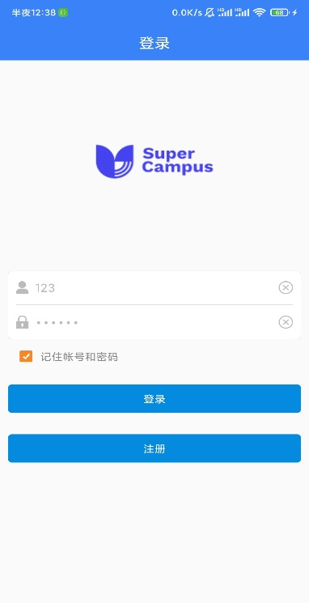 After installation, the user can click the desktop icon to enter the app login page, as shown in the figure：

## 3.3 User registration

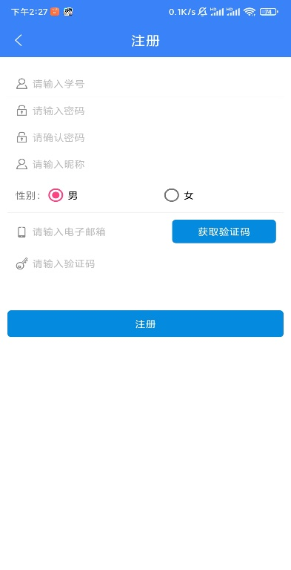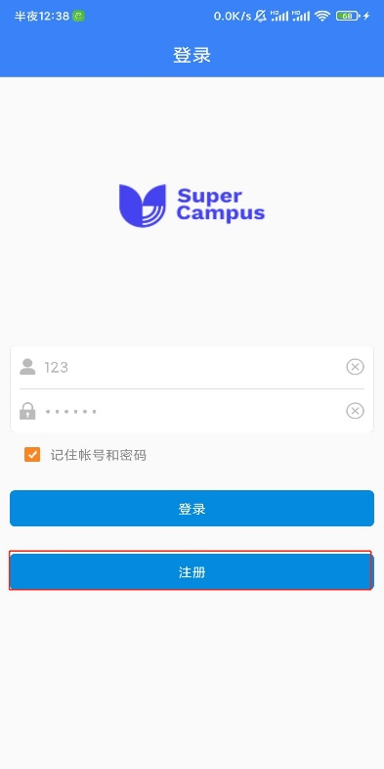 When the user visits for the first time, the user shall register through the following steps: click the desktop icon → register at the bottom of the interface → registration interface → enter student ID personal information → enter e-mail → Click to obtain verification code → enter verification code → register. The interface is as shown in the figure：

## 3.4 Sign in

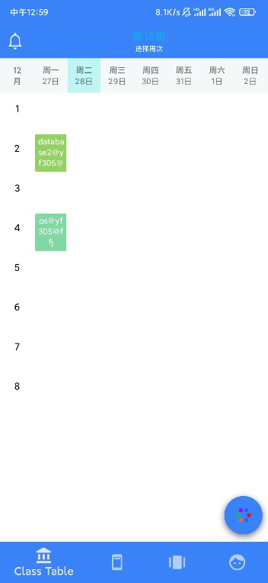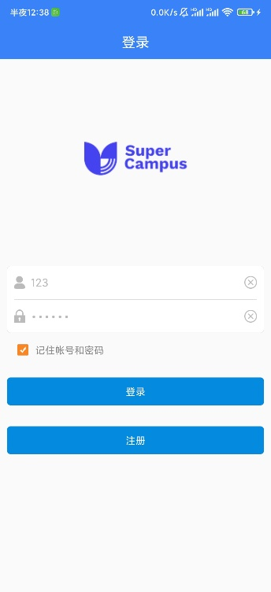 Users who have successfully registered can log in through the following steps: click the desktop icon → enter user name and password → click login to enter the course schedule interface, as shown in the figure：

## 3.5 Course details

Users who log in successfully enter the course schedule interface and click any box to enter the course details interface to operate the course information, as shown in the figure：

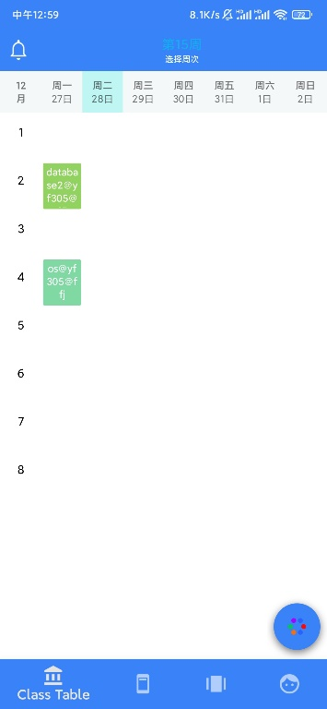

## 3.6 Lost and Found

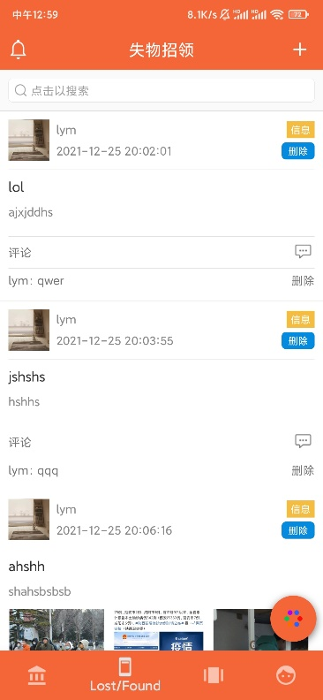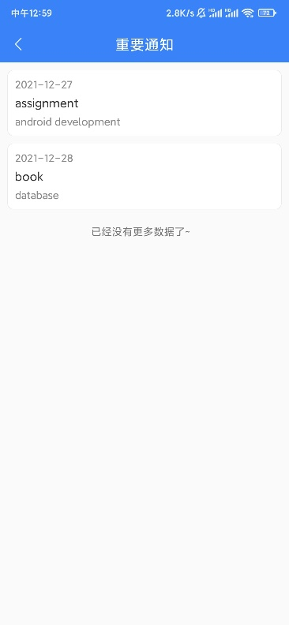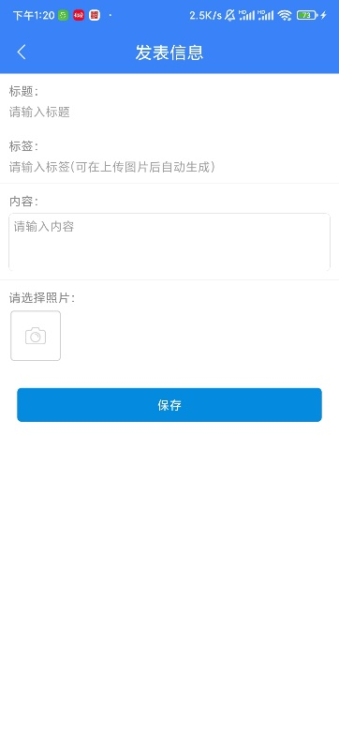 After logging in, click the navigation bar to enter the lost and found interface to view the currently published lost and found information. In the search element bar, you can search the published lost and found information, view important notices in the upper left corner, and publish lost and found information with the "+" sign in the upper right corner, as shown in the figure：

## 3.7 Information wall

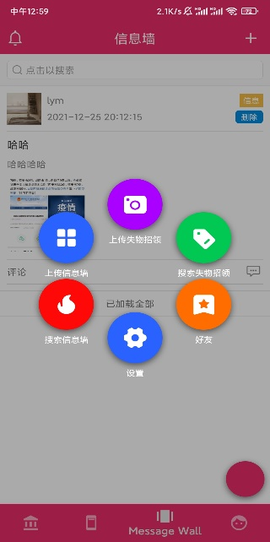 Log in and click the navigation bar to enter the information wall interface. You can view the published information, search the information table and interact with your friends. The interface is shown in the figure：

## 3.8 Friend

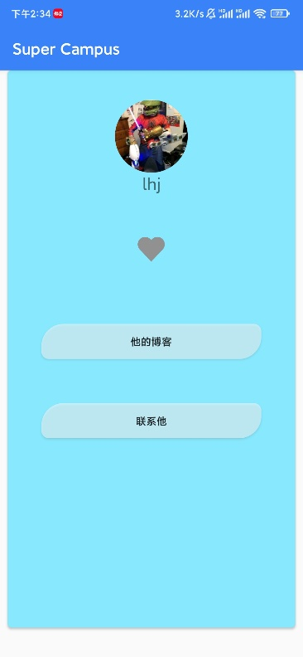 Click friends in the information wall to enter the friends page. You can view friends' blogs or send messages to friends. Slide left and right to switch friends. The interface is shown in the figure：

## 3.9 Personal information

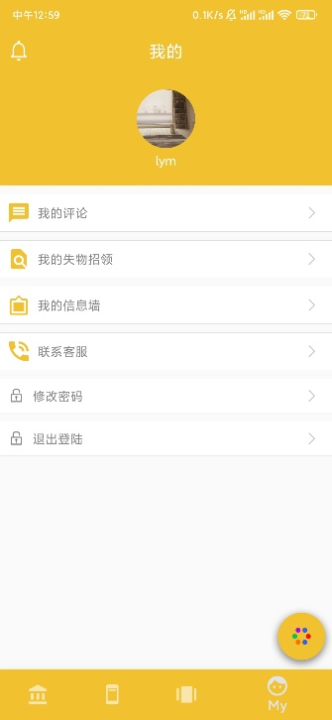 After logging in, click my in the navigation bar to enter the personal information interface. You can change the avatar, view your published information, contact customer service, change the password and exit the login. The interface is shown in the figure：